[CURRENT DATE]

[OCR LEAD TENANT CONTACT_NAME]
[CONTACT_MAILINGSTREET]
[CONTACT_MAILINGCITY] [CONTACT_MAILINGPOSTALCODE]
[CONTACT_MAILINGCOUNTRY]

Dear [LEAD TENANT CONTACT], [TENANT CONTACT – repeat for each]

re: [CONTRACT_FLAT_NO, CONTRACT_STREET_NAME, CONTRACT_CITY, CONTRACT_POST_CODE]

I refer to your tenancy of the above premises and now enclose herewith Housing Act 1988 Section 13 (2) Notice proposing a new rent under an Assured Periodic Tenancy.

The guidance notes for tenants are printed on the reverse of this notice, please read carefully. If you do not accept the proposed rent you may refer the notice to the First Tier Tribunal, you must do this before the starting date of the proposed new rent in paragraph 4 of the notice.

Please be advised that your rent will increase to £[OPPORTUNITY.FIRST_MONTH_RENTAL __C] [NEW PAYMENT FREQUENCY] with effect from [CONTRACT_STARTDATE]. I can confirm that this letter should be used for the purpose of any housing benefit entitlement.

Should you pay your rent by standing order, please remember to contact your Bank to amend the payment account.

I am writing on behalf of [CONTRACT_LANDLORD_NAME] which is a subsidiary of Grainger plc.

Yours sincerely,

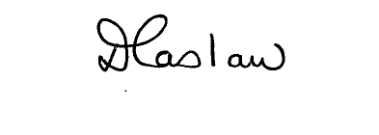

Deborah Caslaw
Tenancy Progressor

T (0191) 2695903
E dcaslaw@graingerplc.co.uk

